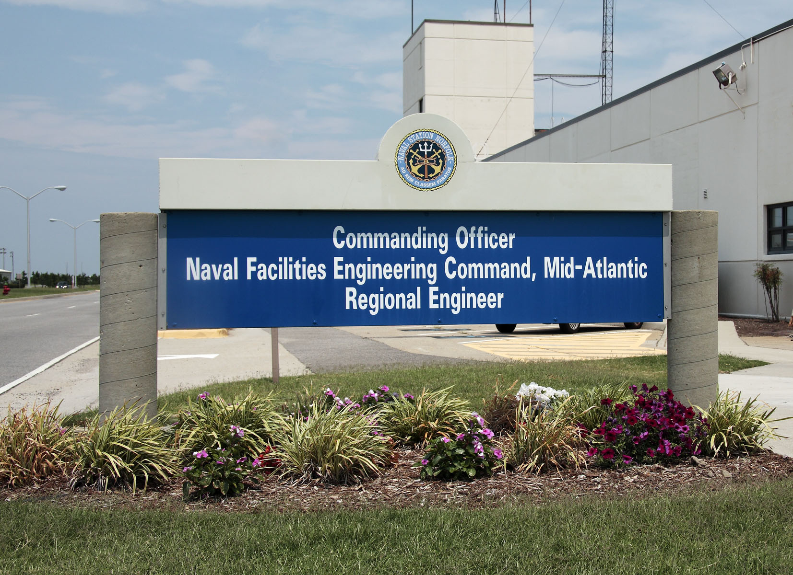
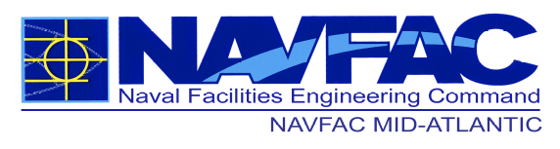

Southeast Offices

Ms. Nakiba Jackson*
FEAD Albany
Walker Avenue Building 5500
Marine Corps Logistic Base, GA 31704
E-Mail: nakiba.jackson1@navy.mil
Phone: 229-639-6403

Mr. Donald L. Herschberger*
FEAD MCAS Beaufort
Bldg. 616 Moore Street
P.O. Box 9310
Beaufort, SC 29904-910
E-Mail: don.herschberger@navy.mil
Phone: 843-228-8574 Fax: 843-228-8590

Mr. Dale Rieck*
FEAD MCRD Parris Island
Bldg. 852 Atsugi Street
Beaufort, SC 29905
E-Mail: dale.c.rieck3@navy.mil
Phone: (314) 626-6395

NAVFAC MID-ATLANTIC’s OFFICE OF SMALL BUSINESS PROGRAMS

Mr. Keith Logan
Assistant Deputy for Small Business
NAVFAC Mid-Atlantic
9324 Virginia Avenue, Building Z140
Norfolk, VA 23511-3096
E-Mail: keith.o.logan@navy.mil
Phone: 757-341-0092 Fax: 757-341-0079

Ms. Kimberly Vallone
Assistant Deputy for Small Business
ROICC Camp Lejeune
1005 Michael Road
Camp Lejeune, NC 28547-2521
E-Mail: kimberly.vallone@navy.mil
Phone: (910) 451-2582 Ext 5289
Fax: 910-451-5899

Revised: October 2017

WHAT WE DO
Plan, design, and construct shore facilities for the U.S. Navy and Marine Corps. Provide expert technical support related to environmental issues, real estate, facilities maintenance, utility and energy systems, transportation and housing.

DOING BUSINESS WITH US
We do not have a preferred vendor list. Contact the NAVFAC Mid-Atlantic Small Business Office or one of its components to discuss your capabilities, interests and company focus with the Small Business Specialist. Please make an Appointment.

Bring a copy of your capability statement, company’s brochure, flyer, and business card.

NAVFAC MIDLANT posts Sources Sought Notices/RFPs and/or Solicitations to the FedBizOpps Website at http://www.fbo.gov and Navy Electronic Commerce Online at https://www.neco.navy.mil/

Visit the NAVFAC Small Business Program Office webpage for all you need to know about Contracting with the Government and our opportunities at
http://smallbusiness.navfac.navy.mil

www.navfac.navy.mil

Mr. Eric Bishop
Supervisory Contract Specialist
PWD Maine
Building 59
Portsmouth Naval Shipyard
Portsmouth, NH 03801
E-Mail: eric.bishop@navy.mil
Phone: 207-438-4184, Fax: 207-438-2916

Vacant
Facilities Engineering & Acquisition Division
Public Works Department
Newport Naval Base
Building 1, Simonpeitri Drive
Newport, RI 02841-1712
Fax: 401-841-1349

Ms. Tracy Gates
Facilities Engineering & Acquisition Division Public Works Department
Naval Submarine Base New London
Box 36, Bldg 135
Groton, CT 06340
E-Mail: tracy.gates@navy.mil
Phone: 860-694-4557 Fax: 860-694-4565

Mr. Anthony Pavese*
Facilities Engineering & Acquisition Division New Jersey Public Works Department, Earle Naval Weapons Station Earle, Bldg C-9
201 Highway 34
Colts Neck, NJ 07722-5025
E-Mail: anthony.pavese@navy.mil
Phone: 732-866- 2152 Fax: 732-866-1011

Mr. Sean Duffy*
Facilities Engineering & Acquisition Division Public Works Department
4921 S. Broad Street, 2nd Floor
Philadelphia, PA 19112-1387
E-Mail: sean.m.duffy1@navy.mil
Phone: 215-897-2613
Fax: 215-897-6932

NAVFAC MID-ATLANTIC SMALL BUSINESS SPECIALISTS

Ms. Whitney Walker*
Facilities Engineering & Acquisition Division
Public Works Department, Norfolk
Building Z-140, Room 309
9324 Virginia Avenue
Norfolk, VA 23511-3689
E-Mail: whitney.walker1@navy.mil
Phone: 757-341-0555 Fax: 757-341-0616

Ms. Kathy Pope*
Facilities Engineering & Acquisition Division
Public Works Department, Yorktown
Naval Weapons Station
PO Drawer 160-NWS
Yorktown, VA 23691-0160
E-Mail: kathy.pope@navy.mil
Phone: 757-887-4705 Fax: 757-887-4200

Kathy Schanze*
Facilities Engineering & Acquisition Division
Public Works Department
Norfolk Naval Shipyard, Portsmouth
Building 491
Portsmouth, VA 23709-5000
E-Mail: Kathy.schanze@navy.mil
Phone: 757-396-1010
Fax: 757-396-2137

Mr. LeRoy Rushing*
Facilities Engineering & Acquisition Division
Public Works Department
Joint Expeditionary Base Little Creek
1450 Gator Blvd. Suite 150
Virginia Beach, VA 23459-3023
E-Mail: Leroy.rushing@navy.mil
Phone: (757) 462-5347
Fax: 757-462-7878

Ms. Natalie Augsburger*
Facilities Engineering & Acquisition Division Naval Air Station Oceana
953 Hornet Drive, Suite 213
Virginia Beach, VA 23460-5121
E-Mail: natalie.augsburger@navy.mil
Phone: 757-433-2668 Fax: 757-433-2423

North Carolina Offices Ms. Kimberly Vallone
ROICC Camp Lejeune
1005 Michael Road
Camp Lejeune, NC 28547-2521

Facilities Engineering & Acquisition Division
Marine Corps Air Station
PSC Box 8006, Building 163
Cherry Point, NC 28533-0006

Midwest Offices
Mr. Ken Seymour
NAVFAC MIDLANT--PWD Great Lakes
2625 Ray St., Bldg. 2016
Great Lakes, IL 60088
E-Mail: Kenneth.d.seymour@navy.mil
Phone: 847-688-5395 Ext 248

Mr. Ken Seymour
MARFORRES Facility Support Team
520 Dewey Ave, Building 5,
Great Lakes, IL 60088-3147
E-Mail: Kenneth.d.seymour@navy.mil
Phone: 847- 688-5395 Ext 248

Ms. Debra S. Dills
MIDLANT PWD Crane
Naval Support Activity
300 Highway 361 B#2516
Crane, IN 47522-5001
E-Mail: debbie.dills@navy.mil
Phone: 812-854-3234 Fax: 812-854-3800

*Small Business Specialist is also Head
of Contracts for this office.

